**Blog Writing Requirements**

|  |  |
| --- | --- |
| Blog topic: | How to Test Your MVP without Significant Investment |
| Blog category: | Website |
| Blog Keywords | Test MVP |
| Sample blogs link: | https://rubygarage.org/blog/how-to-validate-an-mvp |
| Reading time | 12 min |
| Readers type: | Startup decision makers |
| Industries | None. |
| Required word counts: | 2550 |
| Writers Area | |
| Total Word Count (Include Blog, Social, Email count) |  |

**Objective of the blog:**

A goal focused blog addressing potential customersbelongs to a specific industry, their problems – highlighting their specific issues/problems, connecting problems with losses, providing possible solutions, concluding whole topic with objective to achieve…

Notes: final draft should have a sample of all the necessary assets (style formatting, images, and any special instructions for the designer) required to post on the website.

Tags or labels should be mentioned separately

Write Blog Here…..

Instruction for writer:

Image: Use relevant images that support paragraph content, the way used in priority reference link.

Tags: During development avoid web application mistake

Always write content in same/one file.

----------------------------------------------------------------------------------------------------------------------------

**How to Test Your MVP without Significant Investment**

**What is MVP:**

The concept of a Minimum Viable Product (MVP) was popularized by Eric Ries in his book ‘The Incline Startup’. His definition of MVP is “The Minimum Viable Product is that the adaptation of a modern items that a have not too much features but accepted by the customers in the early development cycle of product.

MVP could be a implies to test the item simply during its development phase and to be launching within the advertise. A key premise behind the idea of MVP is that you produce an actual product (which may be no more than a landing page, or a service with an appearance of automation, but which is fully manual behind the scenes) that you can offer to customers and observe their actual behavior with the product or service. Seeing what people actually do with respect to a product is much more reliable than asking people what they would do.

Implies a item that has basic highlights and more often than not, no clients need to utilize or purchase it. Practical is the item that a engineer dreams of making with the assistance of available resources to fulfill the requirements of clients. So the term MVP implies a way to construct such a product that has all the highlights and at the same time, has used less assets. It moreover ought to be able to urge legitimate input which is how the ultimate item will be developed.

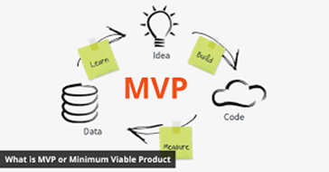

**Five traits of a successful MVP:**

1. MVP success criteria is accomplished when the MVP is centered on one person. This implies that a buyer persona is utilized to target the audience and is as particular as characterizing one single individual. Because it is said that keeping in my one individual and solving his issues along with your item gives the most excellent comes about. The greatest botch ordinarily made is building for different groups of onlookers.

2. Indeed in spite of the fact that we are building for one individual, we do ought to tune in to numerous feedbacks. Now and then distinctive suppositions and sees fathom most of the issues. On the off chance that individuals fit into the category of your item, take their criticism seriously.

3. MVP does not cruel you have got to do less and anticipate more. Your MVP ought to be able to grandstand what issues your item can illuminate and how can it unravel them. This is often indeed more imperative in case your item as of now has huge competition.

4. MVP test is fair as critical as building an MVP. It is outlandish to gain cash from a fizzled MVP, no matter how much you attempt. So, make sure testing the MVP is an imperative portion of your improvement process.

5. An MVP is assumed to discover botches and assemble criticism. Keeping the dispatch of the MVP constrained to as less numerous individuals as conceivable is oing to be a astute choice.

**What makes a good MVP?**

Effective MVP’s tend to share comparative characteristics. The foremost important of which could be a membership’s capacity to unravel a problem or deliver an result that addresses the same torment focuses that you just expected your real participation to address.If it doesn’t, you won’t get strong sufficient marker that your enrollment will be of intrigued to your gathering of people.

Another thing to be beyond any doubt approximately your MVP is that it shouldn’t take a part of time to create.You don’t need to spend an pointless amount of time arranging and making it as it were to discover that no one really needs to purchase it.That’s not to say you shouldn’t make it incredible. You completely ought to, but it ought to as it were include negligible forthright work on your part.

Sticking down the proper cost is imperative, and I propose charging a figure comparative to what you intend to charge for the ultimate product. Members can either make a single one-off installment (as a rule the identical to your month to month charge for your enrollment) or an yearly installment in case you accept your MVP has the same client lifetime esteem as that of your membership.Whether or not individuals are willing to pay for your MVP approves your thought since in case no one needs to pay for the MVP, they likely don’t need to pay for the real participation either.

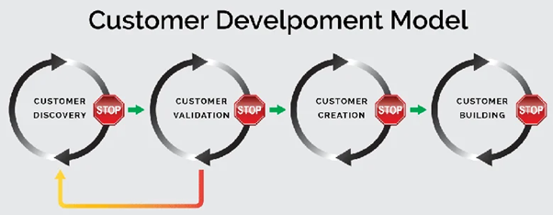

**Why does your product need MVP?**

Who would have envisioned that apps like Twitter, Instagram and Uber would blow up like this and would pick up world ubiquity? We are guessing exceptionally few. In reality, Twitter picked up its notoriety through progressive development. So, why do you would like an MVP?

• **Save Resources:**

When an app is created with numerous highlights and alluring plans, it’s advancement fetched is tall. An MVP is created with constrained resources and is still a item. The fetched of creating an MVP can extend between $10,000 to $20,000. Be that as it may, it can be less than that as well.

• **Define your audience:**

As a startup pulling in modern clients without investing a overwhelming sum on advertisements is very troublesome. MVP for new companies could be a way to bring in more users by investing less. On the off chance that clients discover your item great sufficient, they will communicate it to their companions and that’s how things go viral. Also, when the ultimate item is propelled, getting paid clients from the existing client base ended up possible.

• **Get feedbacks for your product:**

As expressed now in our article, titled “What is Minimum Viable Product “?considering MVP makes a difference with gathering client input. These feedbacks assist gets to be a way to get it how certain highlights ought to be built. And this way, spares the designer the time and taken a toll to go all in with the item whereas guaranteeing way better advertise response.

• **Save time and engage in developement:**

Other exceptionally imperative things that go into making an app are time and exertion of the designer. Envision having went through restless evenings working on an app and when its propelled, it gets exceptionally less footing. It'll be the foremost disillusioning thing for any engineer. It’s better to utilize time and put the effort into building an MVP which is able bring feedbacks.

• **Give clear Roadmap**

In the event that you have got spared a few of million dollars for the ventures at that point you likely may not need MVP to spare cash. But on the off chance that you haven’t at that point MVP could be a extraordinary way of drawing in speculators. It is simple to construct an MVP that raises cash for your app instead of getting no subsidizing for our last item. There are stages like Kickstarter, Indiegogo, AppBackr, etc that give subsidizing for apps.

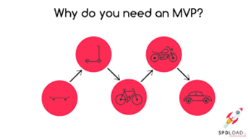

**Mistakes to avoid while building your MVP:**

Indeed in spite of the fact that MVP is built to diminish the chance, there are a few holes that are shaped whereas building an MVP. Maintain a strategic distance from these common botches made most designers.

• **Building for multiple platforms:**

Most new businesses think that building the MVP for all the stages will increment the victory of the real item. But in reality, this is often just progressing to make the method complicated. In case an MVP comes up short at that point the engineer may not have any cash to begin over since all the money was went through on creating for diverse platforms.

• **Features and updates:**

Bringing in clients with one strong include may be a more compelling approach instead of propelling the MVP with all the highlights. Indeed on the off chance that the other highlights are great, they can be brought in afterward within the overhauls. Prioritize the highlights to see the finest comes about and diminish the chances of failure.

• **An improper market, product, customer needs, demographic research:**

What most individuals disregard to do may be a intensive approval of the showcase, thought and the item. Building an MVP is very simple in reality but building a victory MVP is where the huge distinction lies. Without appropriate inquire about around the advertise and the item, the chances of succeeding decreases.

**Testing your MVP:**

The complexity of your MVP depends on the sort of item you're building, and distinctive sorts of MVPs can run from dubious AdWords tests to early prototypes.Once you've got decided the hypotheses you would like to test together with your MVP, here are a few of the testing methods you can put to utilize to urge dependable information from real clients and utilize it. We go into much more noteworthy detail in our Direct to MVPs.

**How to test your MVP:**

Below, we list several beneficial ways to test your MVP to ensure that your business idea is viable.

• **Crowdfunding:**

Crowdfunding is an excellent way when it comes to testing your MVP as to whether it'll do well within the budget or not. Websites like IndieGoGo or Kickstarter offer a incredible stage to run MVP tests. One can create a item utilizing their possess stores to gage the users’ interest and raise funds.

This will encourage offer assistance in propelling the ultimate item to the market. The Stone e-paper smartwatch and Ouya gaming support are the well-known examples who propelled a Kickstarter campaign through crowdfunding. success stories were as of now within the advertise and raising millions of dollars some time recently their dispatch.



• **Pre-Order Pages:**

Like crowdfunding, pre-order page permits you to test your MVP by displaying your item to potential clients. It makes a difference persuade the users to pay for the item in advance, there’s nothing more approving than that.Nonetheless, a few of the clients may not be enthusiastic to invest their cash on the item that has either entered the advertise or is almost to dispatch. In this way, the introduction of the item must be attractive and appealing.App makers construct mock-ups and depictions almost the item for validation.

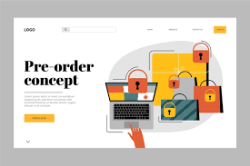

• **Customer Interviews:**

The foremost common way to test a minimum viable product is to urge input from clients who will utilize it. Hold interviews with clients or customers who you target within the market, tune in to their issues to pick up insight that will empower you to require care of repeating issues. This gives the foremost legitimate audits related to your product.

There is all probability that individuals may sugarcoat or lie whereas clarifying their supposition online. But, with a individual meet, there are fewer chances of fake surveys. You'll indeed inquire clients to fill out a overview shape, inquiring on the off chance that the item fathomed their issue and met their desires, and enquiring almost their future desires from the item.



• **Paper prototype:**

Paper prototyping is the primary stage and could be a commonly used method of planning web site or versatile application, and it is additionally free.The main objective at this organize is to construct a competent structure for interaction with the visitor.

A paper model isn't a final plan; you should not draw realistic components in it, embed outlines, or consider the font. Using such a model, you'll be able appear long-standing time site’s structure or application and get moment input from the client. At that point you'll be able conclude the significance of your thought and how to execute it.

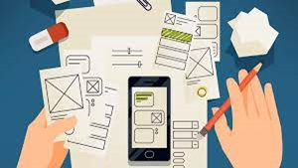

• **Piecemeal MVPs:**

Piecemeal MVPs – a mix of Wizard of Oz and Concierge methods – implies building a demo of your item with the assistance of the existing tools. Rather than contributing time and cash into building anything on your possess, construct an MVP using other existing stages and services.

Groupon is the leading case of a piecemeal MVP. Groupon was at first built on WordPress, Apple Mail, and an AppleScript that made PDFs manually as orders were gotten from the site. In this way, the exertion and taken a toll of building an MVP turn out to be less than anticipated.

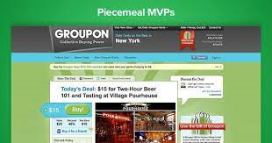

• **Landing Pages:**

Landing pages are the pages, where one can exhibit their brand’s or product’s center highlights and inquire guests to sign up. A landing page can appear the intrigued of the potential clients by the way they carry on and connected on the page.

Building a landing page ought to continuously be followed by following guests analytics by means of instruments like Google Analytics, KISSmetrics, CrazyEgg, and so forth. Moreover, it’s a extraordinary way that lets you test your MVP item against the customers’ desires from the item within the advertise. You even require a practical value-proposition and calls to action.

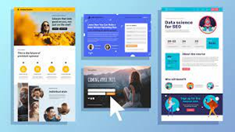

• **Explainer Videos:**

Make recordings and lock your clients could be a great way to test your MVP. Make a brief video that clarifies your item to your target audience. It illustrates how customers will utilize your item and how it'll resolve their torment point. This makes a difference increment the number of signups even before the item launch.

Dropbox, an easy-to-use record sharing device, may be a awesome illustration who utilized explainer video to test their MVP and driven to victory. Dropbox began with an enlivened explainer video with sufficient detail to spur 75,000 individuals to sign up for the beta adaptation of their item

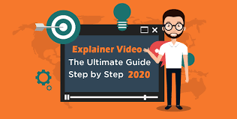

• **Ad Campaigns:**

Advertisement campaigns are an unimaginable way of running business and get approval from customers. Google and Facebook are the stages that empower you to penetrate dwn socioeconomics to the particular target group of onlookers. This gives you a chance to run a low-fidelity test to see what is most engaging approximately your product.

You can indeed distribute the advertisements some time recently the dispatch of a item, or indeed on your landing pages to see the footing on the advertisement, and how numerous clients lock in together with your item. You can indeed distribute the advertisements some time recently the dispatch of a item, or indeed on your landing pages to see the footing on the ad, and how numerous users lock in along with your item. There are indeed devices to analyze clicks, engagement, and other critical behaviors.

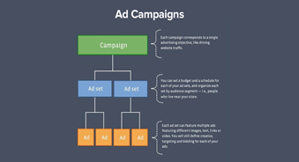

• **A/B Testing:**

A/B testing is an approach to test whether one adaptation is more viable than the other. This test ought to be best conceivable for landing pages, Mail showcasing campaigns, bulletins, apps, blogs, web advertisements, and so on. With the assistance of devices such as Unbounce, Google Analytics, and the like, information can be collected.

A/B testing can assist you select the finest out of the given adaptations, and offer assistance increment transformations on your website. For occurrence, on the off chance that a couple of customers like adaptation A more than adaptation B, you'll get to know that it is progressively practical to utilize for your target gathering of people.

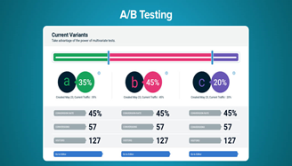

• **Single-feature MVPs:**

Include your least reasonable item to spare advancement time and exertion as well as preventing clients from getting to be diverted with what the item is fundamentally assumed to be.

Foursquare, for illustration, started with the straightforward thought of letting clients check-in to the social organize with their area and the primary versions of their app reflected this straightforwardness. Buffer begun out with fair Twitter bolster and as it were one account per user.These restrictions assist you contract down the starting clients and center on the more important problems, like testing item and showcase viability instead of stressing around including back for other portable stages.

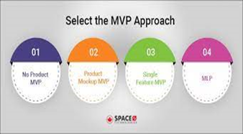

• **Social Media Surveys:**

Social media studies are considered to be the foremost legitimate criticism as they are fast and simple to get to. But, this as it were works once you know your persona well. For case, Facebook studies have a highlight, that empowers clients to incorporate their claim choices as an reply, which gives curiously insights.Another great reason to utilize social-media overviews is to fill out the study shapes so that the clients don’t have go out of their way.



• **Blogs:**

Blogs are a incredible way of approving thoughts with the correct target advertise in negligible exertion. Blogging stage Phantom, and App.net started in concept on their founders’ blogs where they kept on substance out their thoughts and pick up back fro a community of adherents and supporters.



**Conclusion:**

Building , concluding as well as propelling your product by using a MVP methods is just polished your product more in its starting stage.. The primary focus of an MVP is you can gain understanding about your customers’ interest in your product without fully developing the product. The sooner you can find out whether your product will appeal to customers, the less effort and expense you spend on a product that will not succeed in the market.. Make profit from your basic idea only by following these above-mentioned ways to turn your item as the most excellent within the showcase that your target group of customers would adore to utilize. In this article, we shared MVP testing strategies that don’t require noteworthy investments. Utilize them and discover out in the event that your thought will work.